17.Implementing CDMA Encoding/Decoding using MATLAB or Python

1. AIM
To implement CDMA (Code Division Multiple Access) encoding and decoding for multiple users using MATLAB or Python and verify that users can be separated using orthogonal spreading codes.

2. SOFTWARE REQUIRED
You can use either:
- MATLAB (any version)
or
- Python (NumPy)

3. THEORY (Simple)
CDMA
- Multiple users transmit simultaneously using the same bandwidth.
- Each user has a unique spreading code (e.g., Walsh code).
- Data bits are multiplied (spread) by the code.
- Receiver correlates received signal with user’s code → gets back original bit.
Key Idea
$$\text{Encoded Signal}=\text{Data Bit}×\text{Spreading Code} \\ \text{Decoded Bit}=\text{sign}(∑(\text{Received}×\text{Code}))$$
Orthogonality ensures no interference between users.

4. PROCEDURE (Simple Steps)
- Define number of users.
- Assign each user an orthogonal code (e.g., [1 1 1 -1], [1 -1 1 -1]).
- Generate random data bits (+1 or –1).
- Encode each user:
multiply bit × spreading code.
- Add encoded signals → composite CDMA channel signal.
- Decode: multiply composite signal × user code.
- Sum and take sign → original data bit recovered.

5. PSEUDOCODE
users = 2
codes = [code1, code2]
dataBits = [+1, -1]

for each user:
encoded[user] = dataBits[user] * codes[user]

composite = sum(encoded signals)

for each user:
decoded[user] = sign(sum(composite * codes[user]))

CODE
clear; clc; close all;

%% 1. Data bits for two users (BPSK format)
b1 = 1; % User 1 bit
b2 = -1; % User 2 bit

%% 2. Orthogonal Walsh codes (length-4)
c1 = [1 1 1 1]; % User 1 code
c2 = [1 -1 1 -1]; % User 2 code

%% 3. CDMA Encoding (spreading)
s1 = b1 * c1; % Encoded signal of User 1
s2 = b2 * c2; % Encoded signal of User 2

%% 4. Channel: signals add (superposition)
r = s1 + s2;

%% 5. CDMA Decoding (despreading)
d1 = sum(r .* c1); % Correlation with User 1 code
d2 = sum(r .* c2); % Correlation with User 2 code

d1_bit = sign(d1); % Decision for User 1
d2_bit = sign(d2); % Decision for User 2

disp('Decoded Bits:');
fprintf('User 1: %d | User 2: %d\n', d1_bit, d2_bit);

%% 6. Plot Results
figure;

subplot(4,1,1);
stem(c1,'filled'); hold on; stem(c2,'filled','r');
title('Walsh Codes of User 1 & User 2'); grid on;

subplot(4,1,2);
stem(s1,'filled'); hold on; stem(s2,'filled','r');
title('Encoded (Spread) Signals'); grid on;

subplot(4,1,3);
stem(r,'filled');
title('Combined CDMA Signal (Superposition)'); grid on;

subplot(4,1,4);
stem(r.*c1,'filled'); hold on; stem(r.*c2,'filled','r');
title('Despread Signals (Before Decision)'); grid on;
xlabel('Chip Index');

OUTPUT:

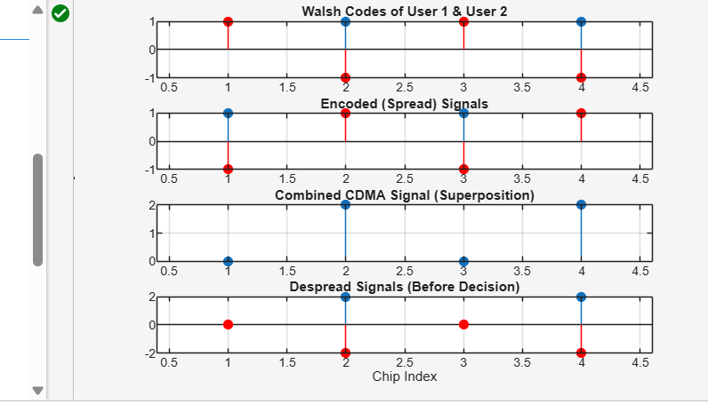

RESULTS
- CDMA encoding spreads user data using orthogonal codes.
- The composite signal contains both users simultaneously.
- Decoding using correlation successfully recovers original bits.

